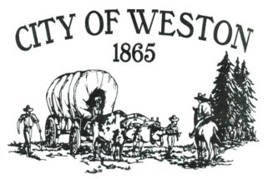

114 East Main PO Box 579 Weston, OR 97886

Tel* (541) 566-3313 *Fax (541) 566-2792

**CITIZEN OF THE YEAR NOMINATION FORM**

Weston’s Citizen of the Year award recognizes an individual who throughout the year(s) has made a sincere effort to be involved and help our community.

1. **NAME OF NOMINEE:**______________________________________________________

Address:_________________________________________________________________

1. **BACKGROUND INFORMATION:**
2. Date of Birth:__________________________________________________________
3. Spouse’s Name:________________________________________________________
4. Children:_____________________________________________________________
5. **DIRECT COMMUNITY SERVICE:** This should include those activities which have resulted in direct community service and improvement. The service may be the result of membership in other organizations. It may also include the candidate’s involvement in his/her chosen religious organization. ________________________________________________________________________________________________________________________________________________________________________________________________________________________________________________________________________________________________
6. **CIVIC INVOLVEMENT:** This may include those activities that do not always result in direct community service, but are integral and supportive aspects of the community. Examples might be political, voluntary government service, or educational support involvement. ________________________________________________________________________________________________________________________________________________________________________________________________________________________________________________________________________________________________
7. **OTHER:**__________________________________________________________________________________________________________________________________________________________________________________________________________________

NAME OF INDIVIDUAL SUBMITTING NOMINATION:

______________________________________________________________________________

Phone # of Submitter:____________________________________________________________

USE ADDITIONAL SHEETS OF PAPER FOR QUESTION #’S 3-5, AS NEEDED.

Please mail form in a ***sealed envelope to:***  PO Box 579, WESTON, OR 97886. You may also drop it off at the Weston Public Library (108 E Main) or City Hall (114 E Main).

**\*\*DEADLINE FOR SUBMISSION: Friday, March 11, 2022.\*\***