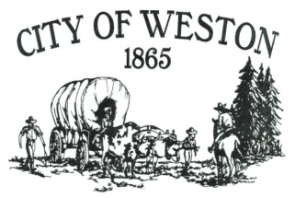
114 East Main PO Box 579 Weston, OR 97886
Tel* (541) 566-3313 Fax* (541) 566-2792
recorder@cityofwestonoregon.com
“This institution is an equal opportunity provider and employer”

MAYOR/CITY Councilor Application DATE________________

Which are you applying for? Mayor _________, City Councilor_______ (Check one)

Name: _______________________________________________________________________

Address (physical and mailing):
_________________________________________City: ________________State: ____ Zip: __________

Phone Number: ( ) - .

Have you been a resident of Weston for 1 year or more? Yes No

Are you a registered voter for the City of Weston? Yes No

Please give a brief statement of your background. __________________________________________________________________________________________________________________________________________________________________________________________________________________________________________________________________

Here are some questions to answer: You may use a separate sheet of paper if needed.

- Why do you want to be a mayor/city council member in Weston?

- What do you feel are your qualifications for this position?

- What do you think the duties of the council are?

- What do you think the duties of a liaison are?

- What do you think the duties of the City Planning Commission are?

- What would be your personal goals to better the City of Weston?

- What have you done for Weston in the past?

References: List three names (non-related).

- Name __________________________________Phone Number (____)__________________

- Name __________________________________Phone Number (____)__________________

- Name __________________________________Phone Number (____)__________________

Applicants may be subject to a criminal background check.

